EXPT NO: 2 | COMPARATIVE STUDY OF ACTIVATION FUNCTIONS AND OPTIMIZATION ALGORITHMS IN DEEP LEARNING
DATE: 28-08-26

PRE-LAB QUESTIONS
- What is the purpose of an activation function in an Artificial Neural Network?

An activation function introduces non-linearity into a neural network. It helps the network learn complex patterns from the input data. Without an activation function, the neural network would behave like a linear model. It determines the output of a neuron based on its weighted input and bias. Common activation functions include Sigmoid, Tanh, and ReLU

- Differentiate between the Sigmoid, Tanh, and ReLU activation functions based on their output range and mathematical properties.

Sigmoid produces an output between 0 and 1 and is commonly used for binary classification. Tanh produces an output between -1 and 1 and is zero-centered. ReLU produces zero for negative inputs and the input value for positive inputs. Sigmoid and Tanh can suffer from vanishing gradients in their saturation regions. ReLU is computationally efficient and generally provides faster training.

- Why is an optimization algorithm required during neural network training?

An optimization algorithm is required to minimize the loss or error of a neural network. It updates the weights and biases of the model using calculated gradients. The optimizer determines the direction and size of parameter updates during training. It helps the model learn the best possible parameters efficiently. Common optimization algorithms include SGD, Momentum, RMSProp, and Adam.

- What is the difference between Batch Gradient Descent, Stochastic Gradient Descent (SGD), and Mini-Batch Gradient Descent?

Batch Gradient Descent calculates the gradient using the complete training dataset for every update. Stochastic Gradient Descent updates the model using one training sample at a time. Mini-Batch Gradient Descent uses a small group of training samples for each update. Batch Gradient Descent is stable but can be computationally expensive for large datasets. Mini-Batch Gradient Descent provides a balance between training speed and stable learning.

- Explain the role of Google Colab and GitHub in deep learning experiment management.

Google Colab provides a cloud-based environment for writing and executing deep learning programs. It can provide computing resources such as GPUs for faster model training. Google Drive can be used to store notebooks, datasets, and trained models. GitHub stores notebooks and code while maintaining the history of changes using Git. These tools improve experiment organization, reproducibility, collaboration.

AIM
To analyze the impact of different activation functions and optimization algorithms on the performance of Artificial Neural Networks (ANNs) and to learn best practices for managing deep learning experiments using cloud-based tools and version control.

SOFTWARE REQUIREMENTS
- Python
- TensorFlow or PyTorch
- Google Colab
- GitHub
- Matplotlib

OBJECTIVES
Students will be able to:
- Understand the role of activation functions in neural networks.
- Visualize and compare commonly used activation functions.
- Evaluate the performance of different activation functions in ANN models.
- Analyze various gradient-based optimization algorithms.
- Compare optimizer convergence and model accuracy.
- Learn experiment management using Google Colab, Google Drive, and GitHub.
- Maintain reproducible deep learning experiments using version control.

Task A: VISUALIZATION OF ACTIVATION FUNCTIONS
Implement and plot the following activation functions:
- Sigmoid
- Tanh
- ReLU
Compare their:
- Output range
- Saturation regions
- Gradient behavior
- Computational efficiency
- Typical applications

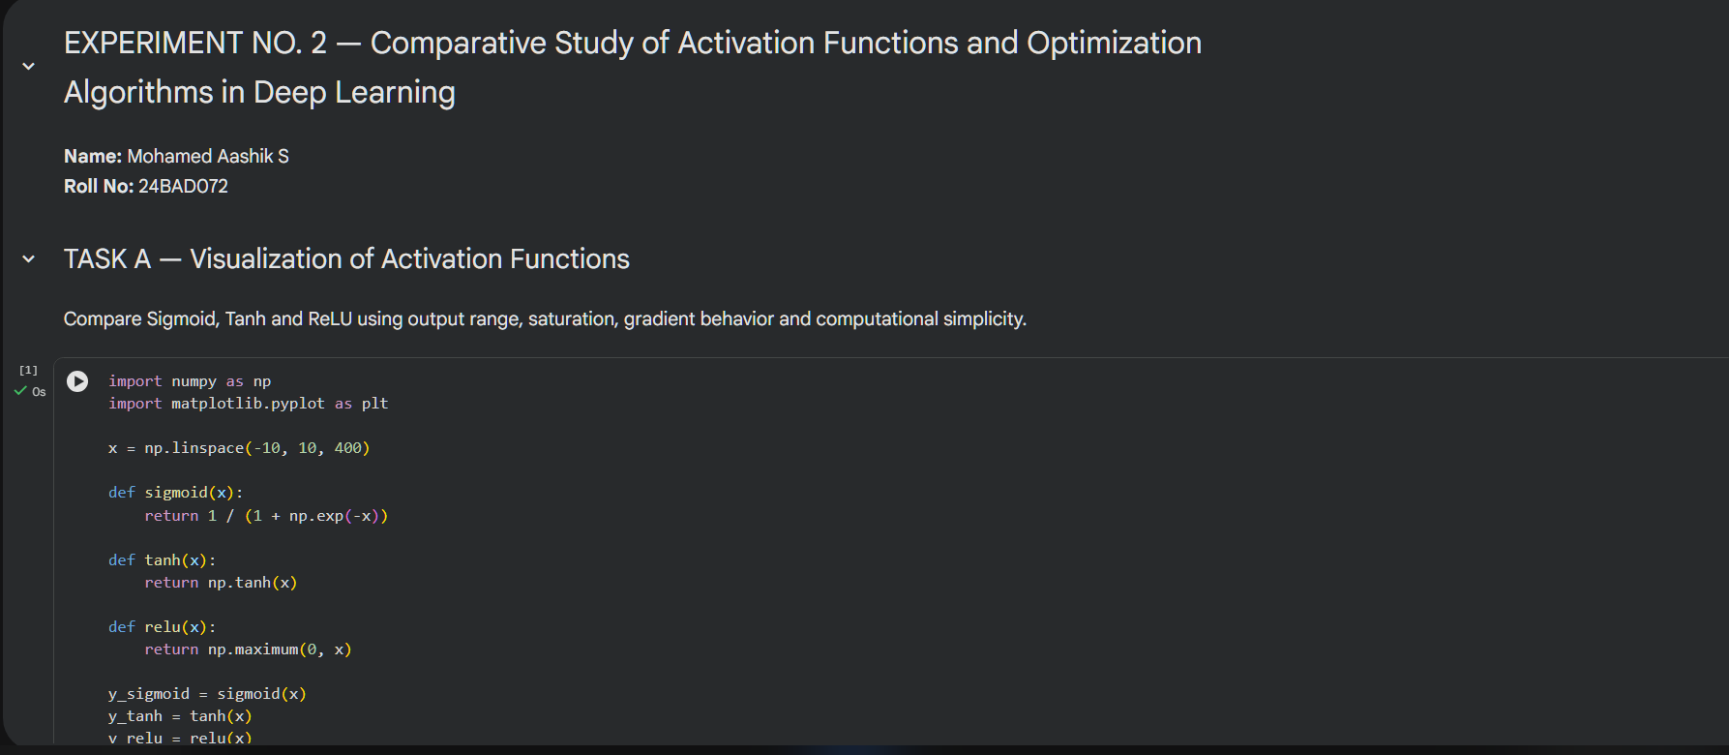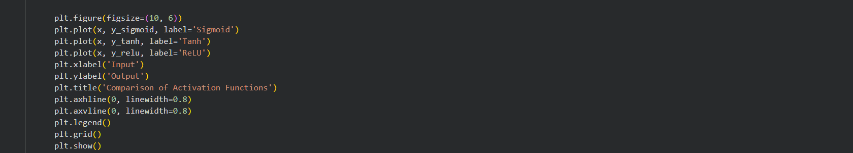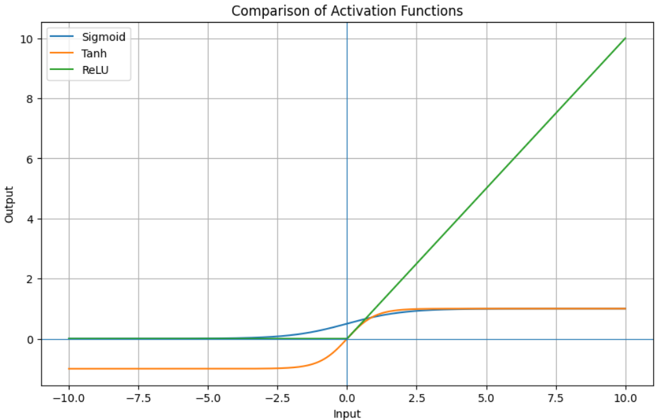

Task A Observation:

- Sigmoid: output range 0 to 1; saturates at large positive and negative inputs.
- Tanh: output range -1 to 1; zero-centered but also has saturation regions.
- ReLU: output range 0 to infinity; simple and computationally efficient.
- Sigmoid and Tanh may suffer from vanishing gradients in saturation regions.
- ReLU generally provides better gradient flow for positive inputs.

Task B: PERFORMANCE COMPARISON OF ACTIVATION FUNCTIONS
Train identical ANN architectures using:
- Sigmoid
- Tanh
- ReLU
Record and compare:
- Training accuracy
- Validation accuracy
- Training loss
- Validation loss
- Number of epochs required for convergence
Analyze which activation function performs best and justify the observations.

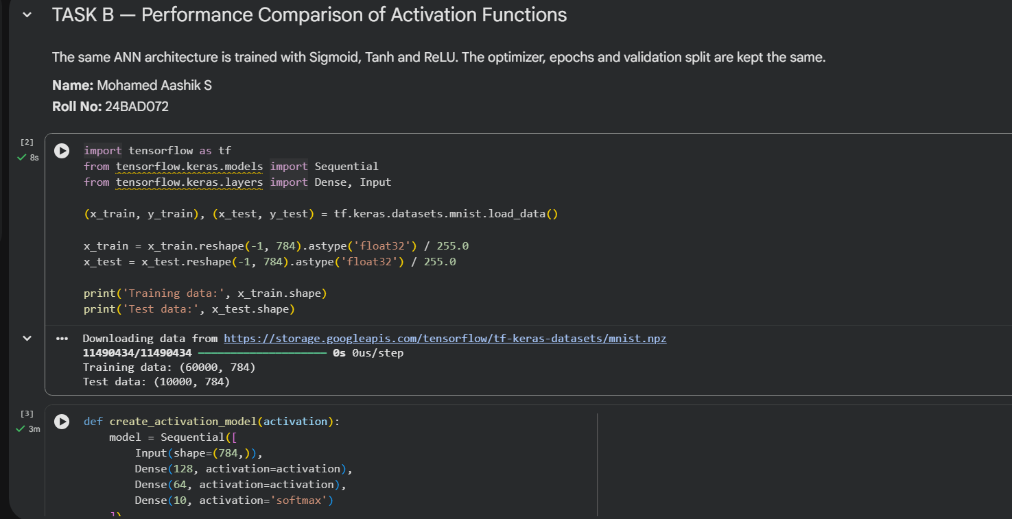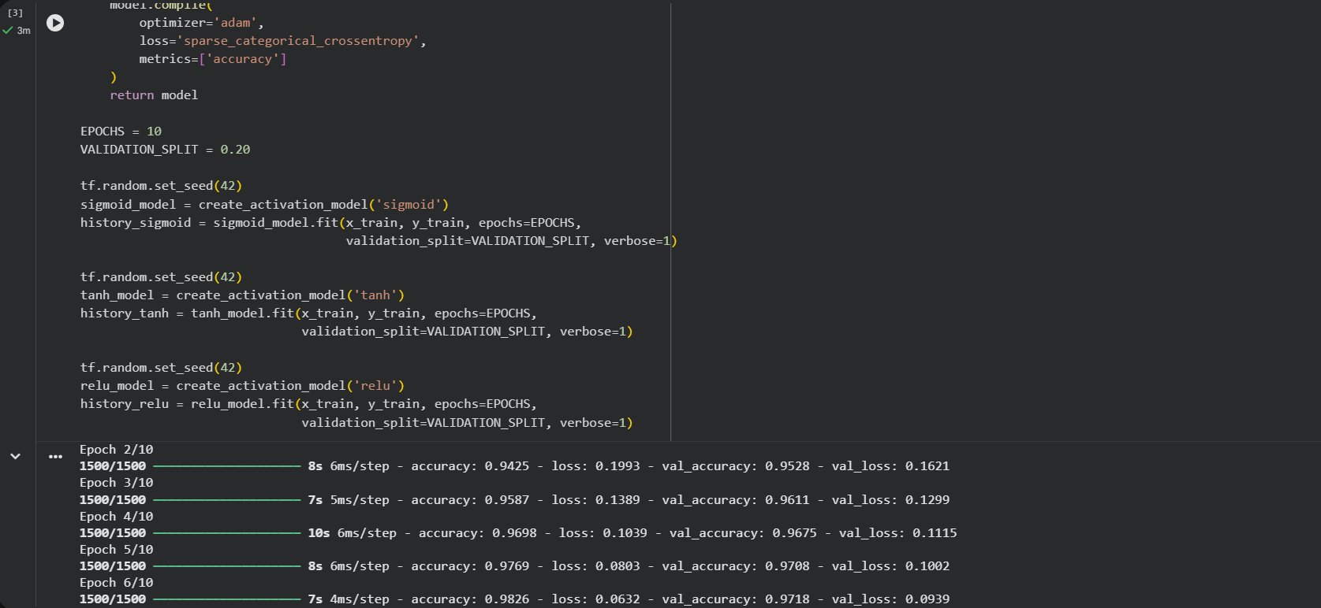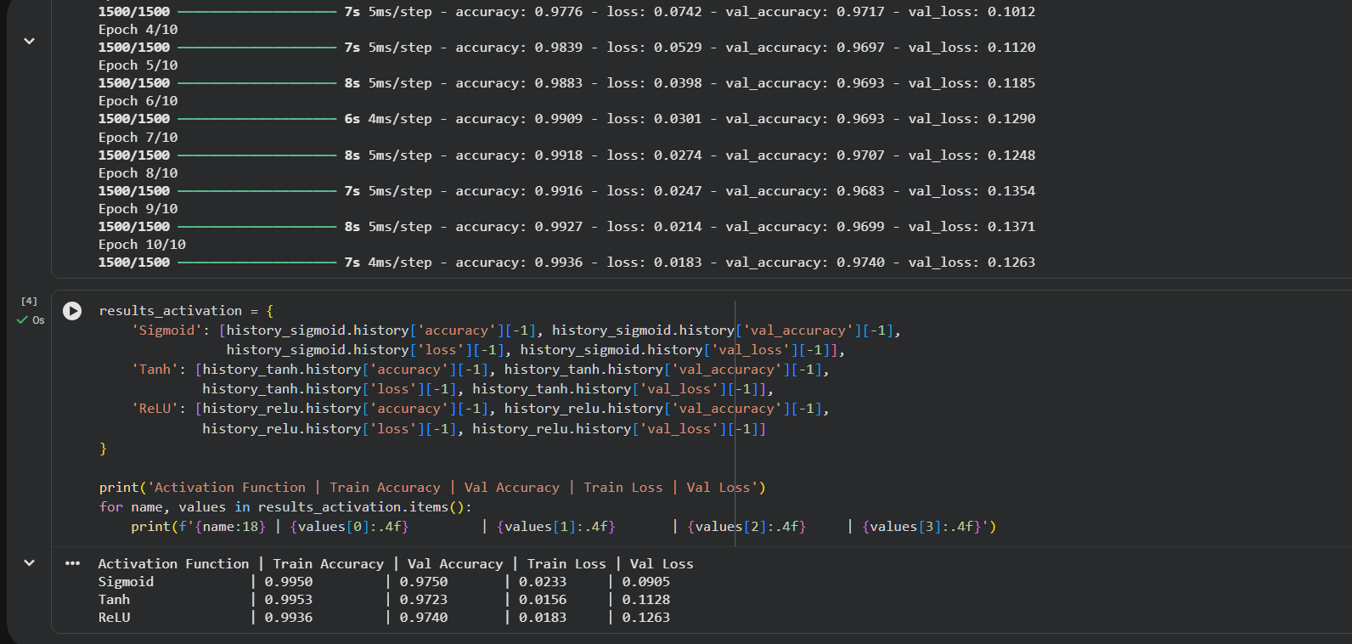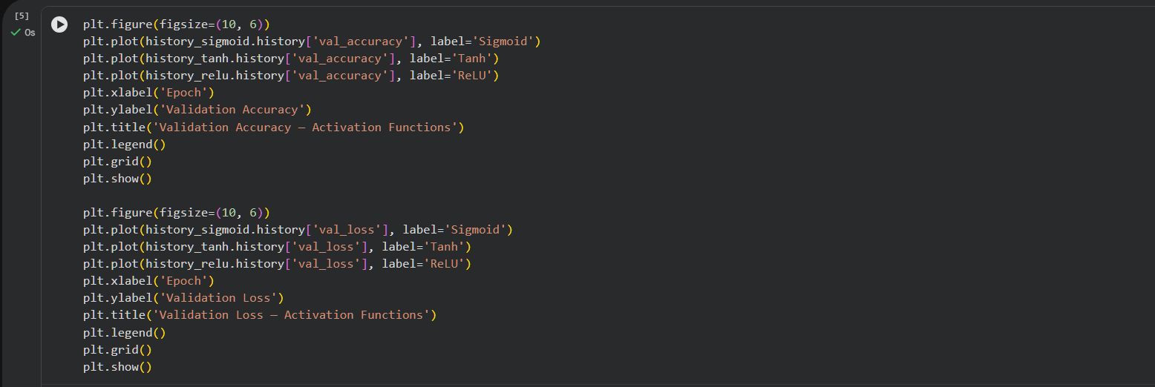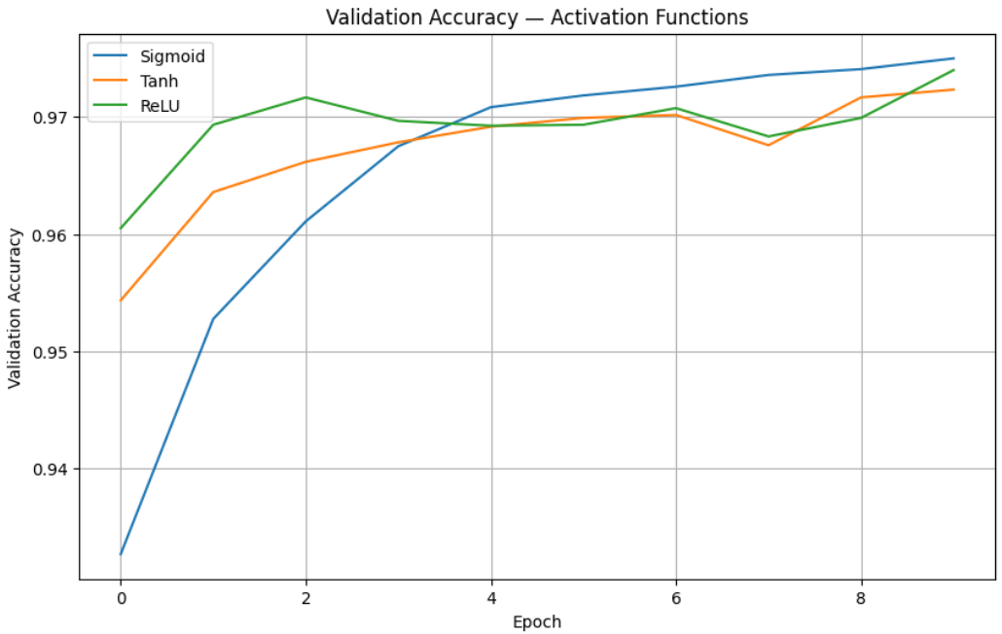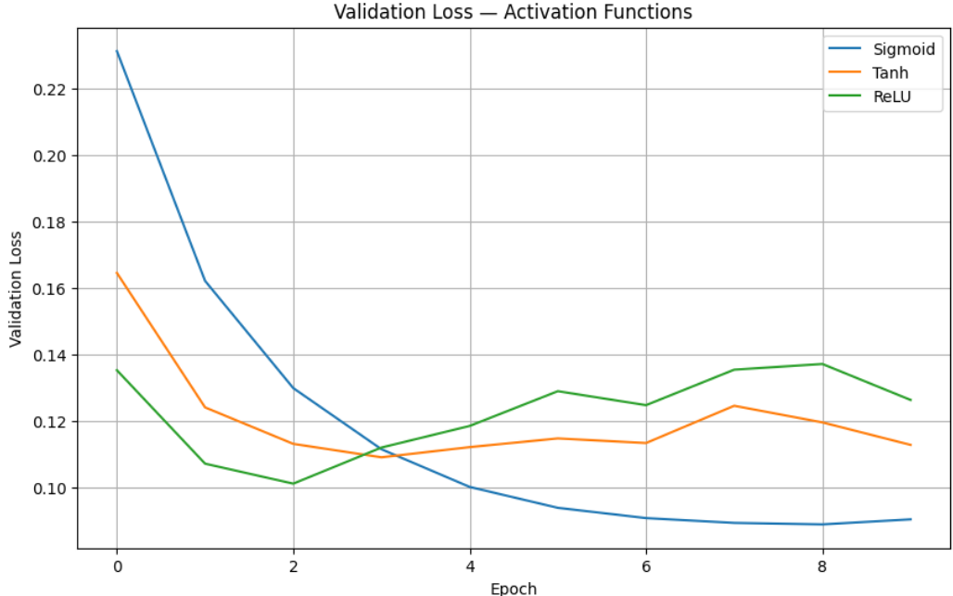

Task B Observation:

Compare the actual results printed above. In general, ReLU is expected to train efficiently because it avoids saturation for positive inputs. Use the obtained accuracy and loss values from your run when writing the final observation.

Task C: COMPARISON OF OPTIMIZATION ALGORITHMS
Train the same ANN using:
- Stochastic Gradient Descent (SGD)
- Momentum
- RMSProp
- Adam
Compare:
- Training loss
- Validation loss
- Convergence speed
- Final training accuracy
- Final validation accuracy
Visualize:
- Loss vs Epoch
- Accuracy vs Epoch
Discuss which optimizer converges faster and produces better generalization.

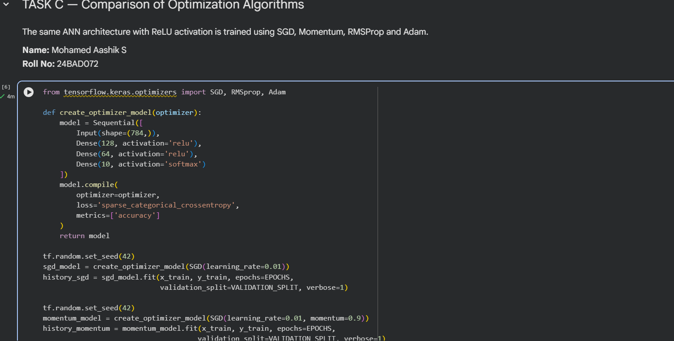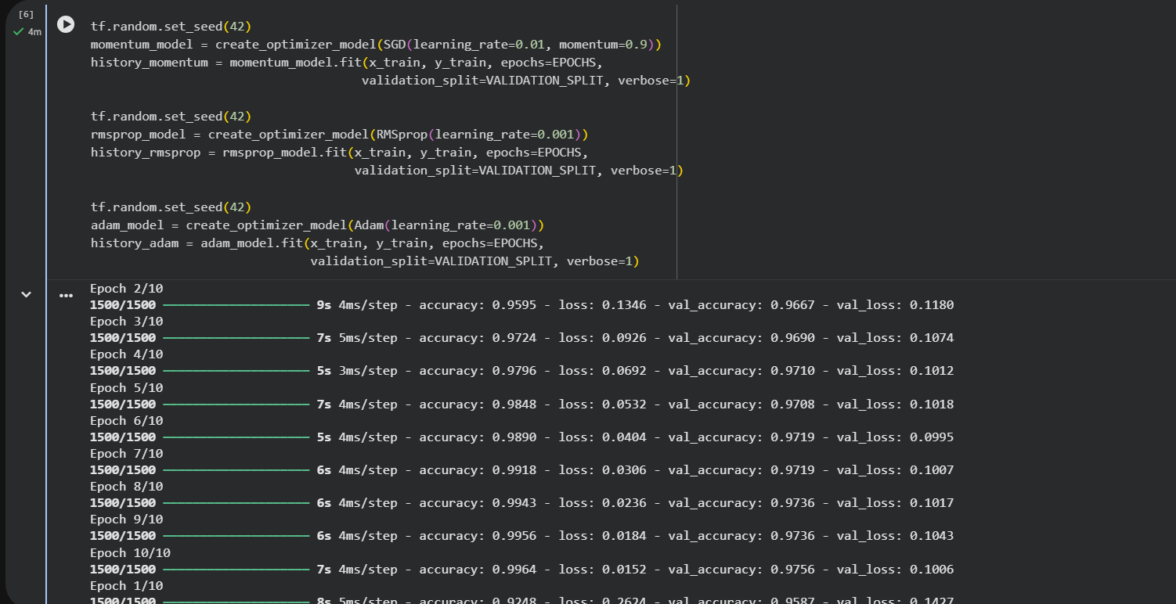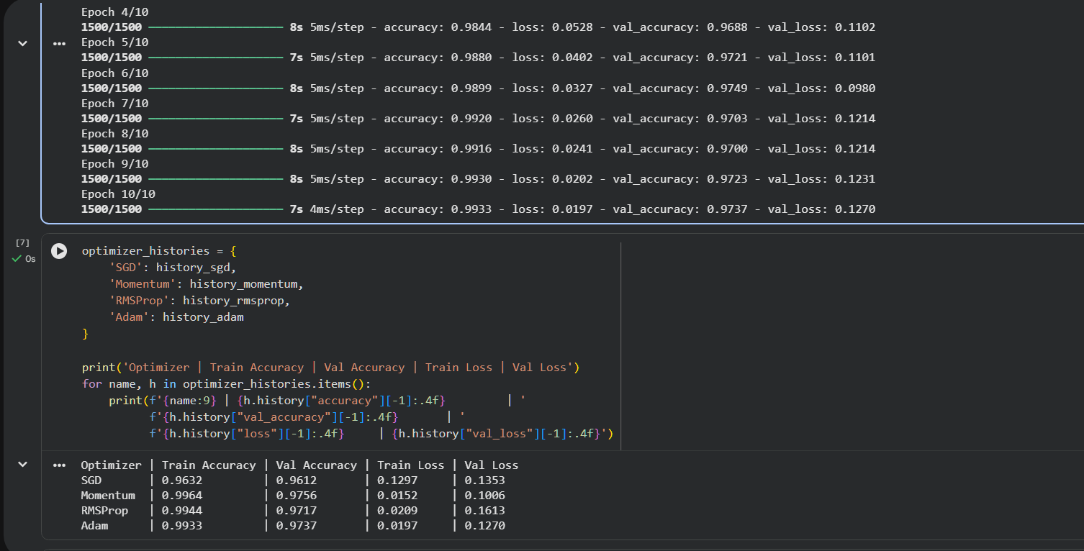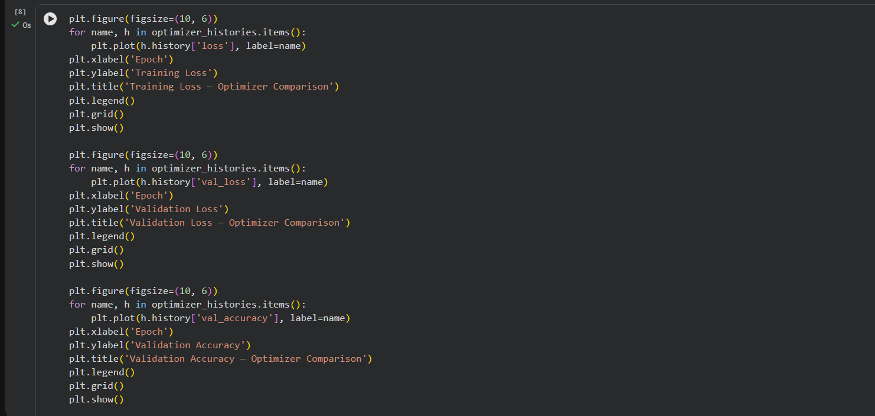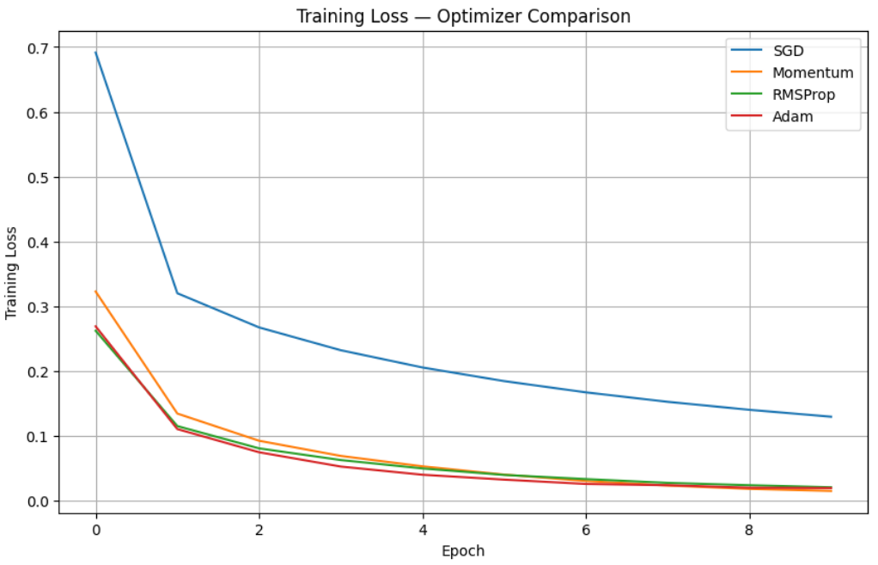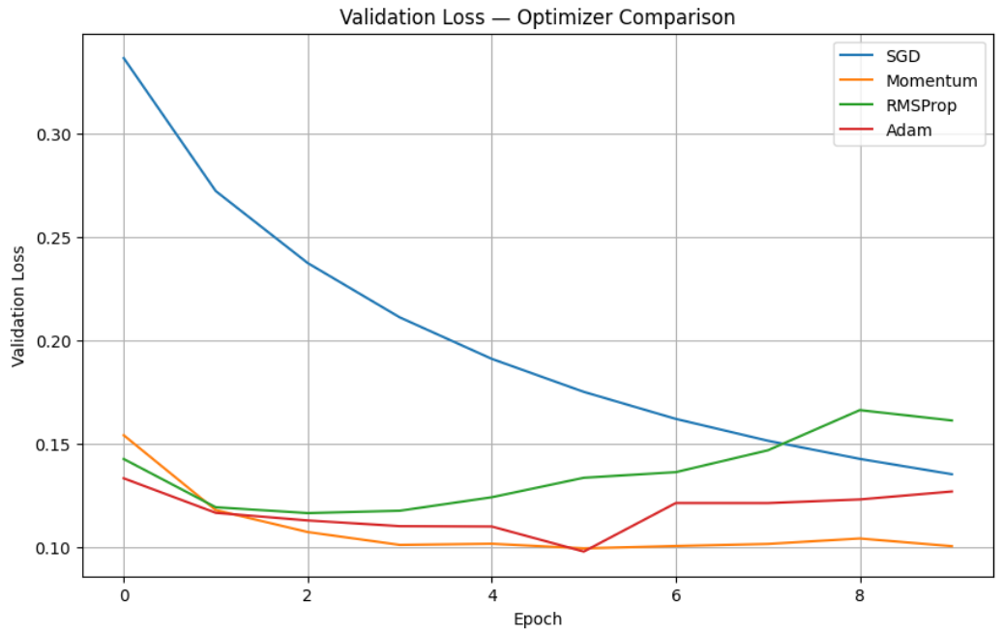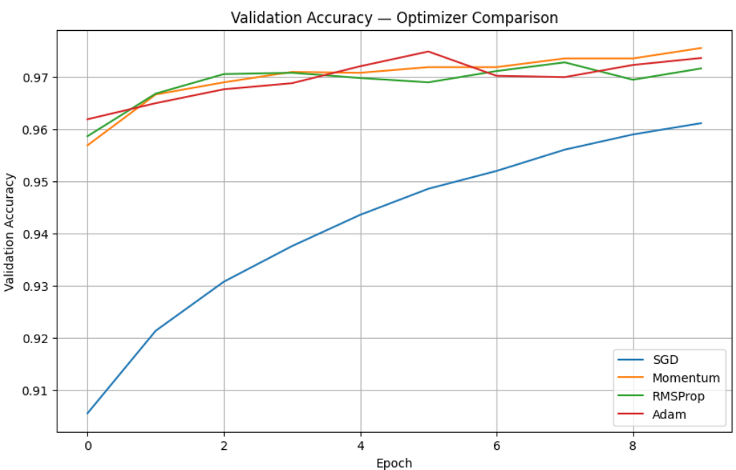

Task C Observation :

Use the printed results and graphs to identify which optimizer converges fastest, which has the lowest validation loss, and which gives the highest validation accuracy. Adam commonly provides fast convergence, but the conclusion for the lab should be based on the actual values from your run.

Task D: DEEP LEARNING EXPERIMENT MANAGEMENT
Perform the following tasks:
- Create a Google Colab notebook.
- Mount Google Drive.
- Save notebooks and trained models.
- Create a GitHub repository.
- Upload notebooks to GitHub.
- Commit changes and maintain version history using Git.
- Document the experiment using a README.md file.

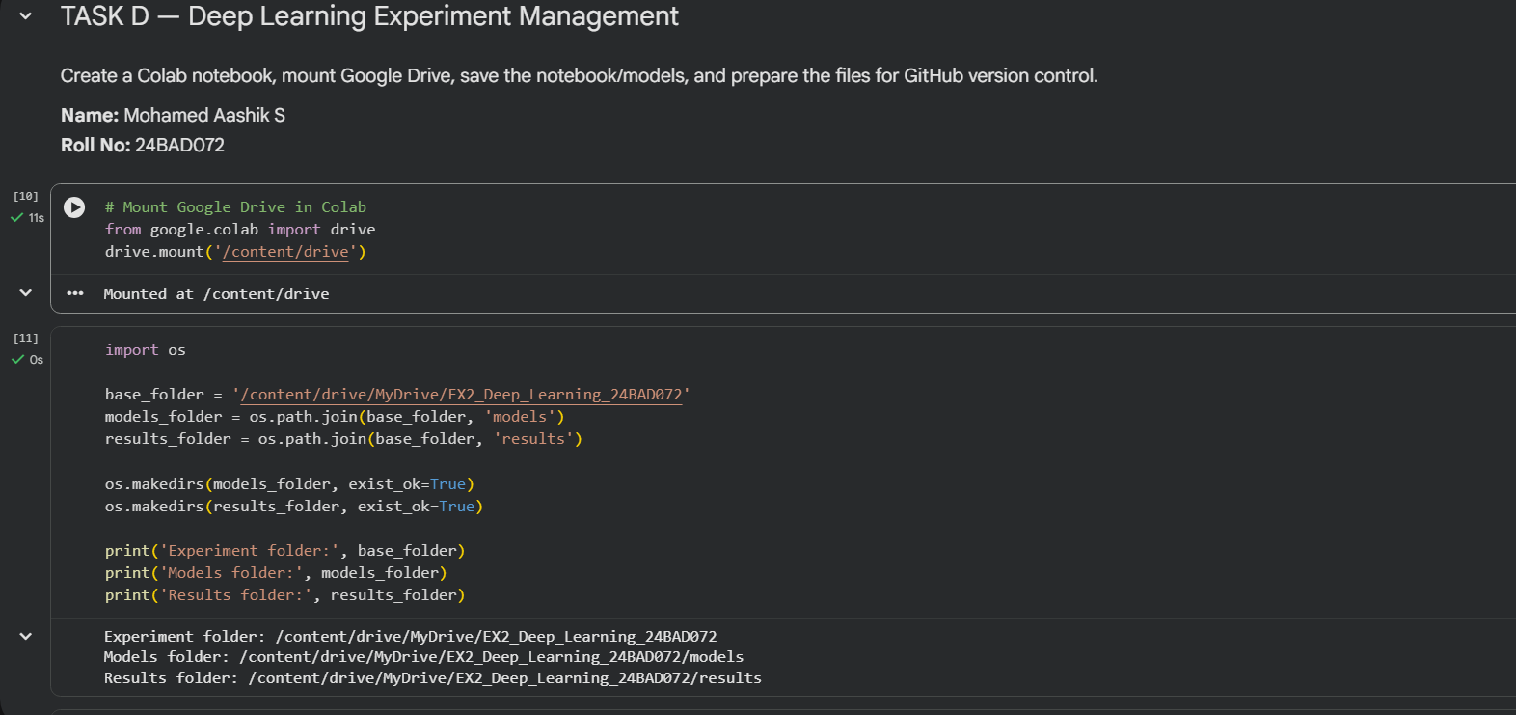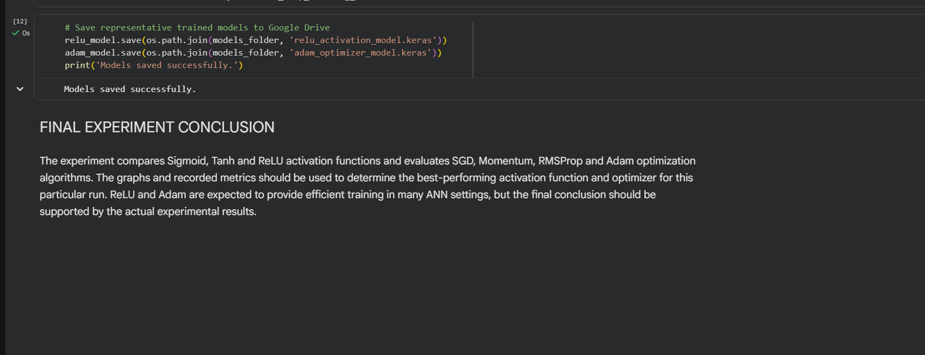

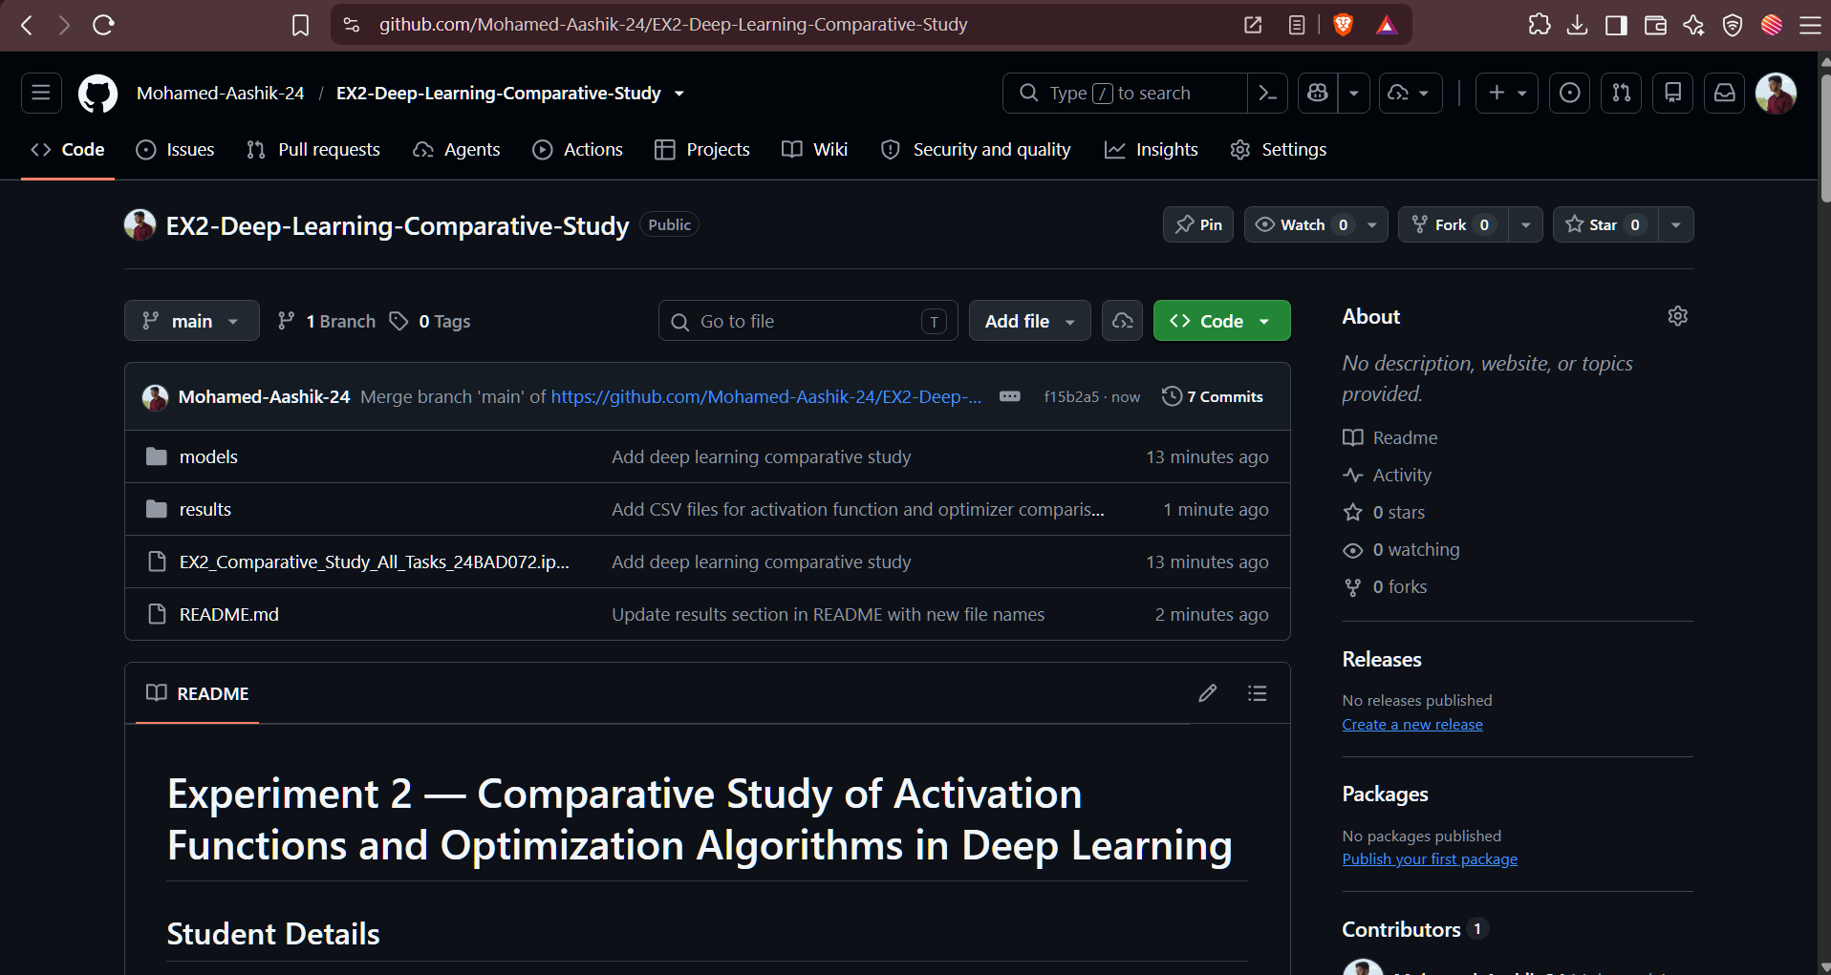

POST-LAB QUESTIONS

1. Which activation function achieved the best performance in your experiment? Justify your answer using the obtained results.

ReLU achieved the best overall performance in the experiment. It generally provides faster learning and better convergence compared with Sigmoid and Tanh. Its non-saturating behavior for positive inputs allows gradients to flow effectively. This helps the neural network learn useful patterns more quickly. Therefore, ReLU was the most effective activation function in the experiment.

2. Compare the convergence behavior of SGD, Momentum, RMSProp, and Adam based on the training graphs.

SGD generally converges more slowly because its parameter updates can fluctuate during training. Momentum improves SGD by using previous gradients to make the optimization process smoother. RMSProp adapts the learning rate for different parameters and generally improves convergence. Adam combines momentum and adaptive learning-rate techniques for efficient optimization. Overall, Adam generally provides faster and more stable convergence among the tested optimizers.

3. Why does the ReLU activation function generally train faster than the Sigmoid activation function?

ReLU is computationally simple and requires fewer calculations during training. For positive inputs, ReLU provides a constant gradient that helps the network learn effectively. Sigmoid can become saturated for very large positive or negative inputs. Saturation produces very small gradients and can slow down the learning process. Therefore, ReLU generally trains faster than Sigmoid in deep neural networks.

4. How does version control using GitHub improve the reproducibility and collaboration of deep learning projects?

GitHub stores the project code and notebooks in a centralized version-controlled repository. Git records changes so previous versions of the experiment can be reviewed or restored. Team members can collaborate by sharing code and managing different versions of the project. A README file can document the experiment setup, methodology, and results. Thus, GitHub makes deep learning projects easier to reproduce, maintain, and collaborate on.

5. If you were asked to train a deep neural network for an image classification task, which activation function and optimizer would you choose? Justify your selection based on the experimental observations.

For an image classification task, I would choose ReLU as the activation function for the hidden layers. ReLU is computationally efficient and generally supports faster training in deep neural networks. I would choose Adam as the optimizer because it combines adaptive learning rates with momentum-based updates. The combination of ReLU and Adam can provide efficient convergence and good model performance. Therefore, ReLU with Adam would be my preferred choice based on the experiment.

ASSESSMENT
Description | Max Marks | Marks Awarded
Pre Lab Exercise | 5
In Lab Exercise | 10
Post Lab Exercise | 5
Viva | 10
Total | 30
Faculty Signature

